- #include <stdio.h>
int main()
{
int n,search,num,i,found=0;
printf("Enter the number of elements:");
scanf("%d",&n);
printf("Enter the element to search:");
scanf("%d",&search);
for(i=1;i<=n;i++) {
printf("Enter element %d:",i);
scanf("%d",&num);
if(num==search)
{
found=1;
printf("Element %d found at position %d.\n",search,i);
break;
}
}
if(!found){
}
{
printf("Element %d not found.\n",search);
}
return 0;
}

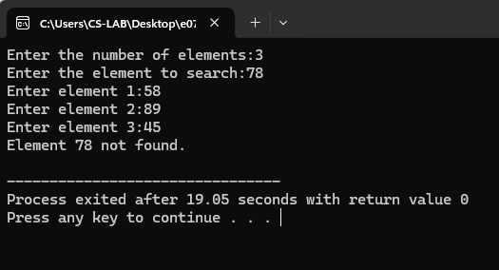

2. #include <stdio.h>
int main() {
int n, i, num;
int largest, smallest;
printf("Enter the number of integers to compare: ");
scanf("%d", &n);
if (n <= 0) {
printf("Please enter a positive number of integers.\n");
return 1; }
printf("Enter integer 1: ");
scanf("%d", &num);
largest = num;
smallest = num;
for (i = 2; i <= n; i++)
{
printf("Enter integer %d: ", i);
scanf("%d", &num);
if (num > largest) {
largest = num; }
if (num < smallest)
{
smallest = num;
}
}
printf("The largest integer is: %d\n", largest); printf("The smallest integer is: %d\n",
smallest);
return 0; }
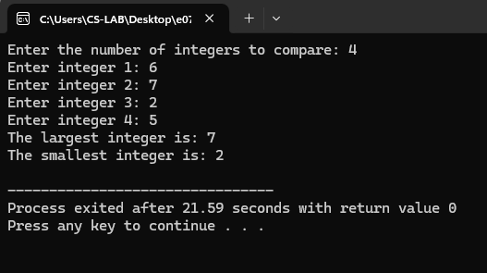

3. #include <stdio.h>
int main()
{
int sum = 0;
for (int i = 1000; i <= 2000; i++) {
if (i % 3 == 0) {
sum += i;
}
}
printf("The sum of all numbers between 1000 and 2000 divisible by 3 is: %d\n", sum);
return 0;
}
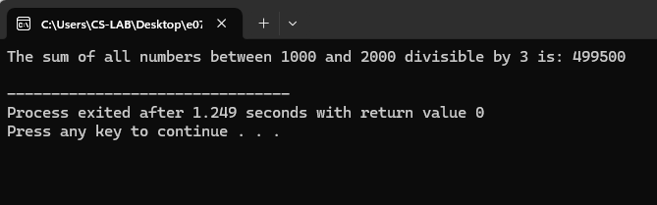

4. #include <stdio.h>
int main() {
int choice;
float num1, num2, result;
do {
printf("\nMenu:\n");
printf("1. Addition\n");
printf("2. Subtraction\n");
printf("3. Multiplication\n");
printf("4. Division\n");
printf("5. Exit\n");
printf("Enter your choice (1-5): ");
scanf("%d", &choice);
switch (choice) {
case 1:
printf("Enter two numbers: ");
scanf("%f %f", &num1, &num2);
result = num1 + num2;
printf("Result: %.2f\n", result);
break;
case 2:
printf("Enter two numbers: ");
scanf("%f %f", &num1, &num2);
result = num1 - num2;
printf("Result: %.2f\n", result);
break;
case 3:
printf("Enter two numbers: ");
scanf("%f %f", &num1, &num2);
result = num1 * num2;
printf("Result: %.2f\n", result);
break;
case 4:
printf("Enter two numbers: ");
scanf("%f %f", &num1, &num2);
if (num2 != 0) {
result = num1 / num2;
printf("Result: %.2f\n", result);
} else {
printf("Error! Division by zero is notallowed.\n");
}
break;
case 5:
printf("Exiting the program.\n");
break;
default:
printf("Invalid choice! Please enter a numberbetween 1 and 5.\n");
}
} while (choice != 5);
return 0;
}
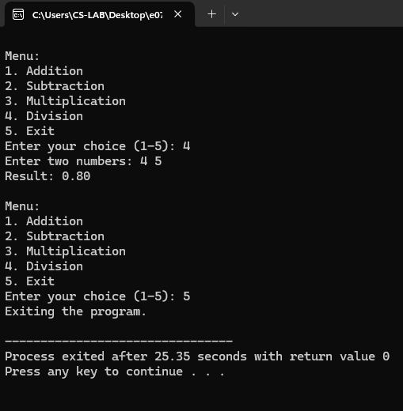

5. #include <stdio.h>
int main() {
int num, originalNum, reversedNum = 0, remainder;
printf("Enter an integer: ");
scanf("%d", &num);
originalNum = num;
while (num != 0) {
remainder = num % 10;
reversedNum = reversedNum * 10 + remainder;
num /= 10;
}
if (originalNum == reversedNum) {
printf("%d is a palindrome.\n",
originalNum); } else {
printf("%d is not a palindrome.\n", originalNum);
}
return 0;
}
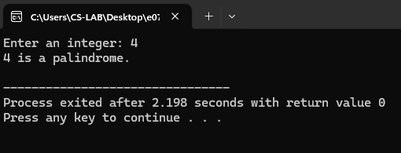

6. #include <stdio.h>
int main() {
int num, originalNum, remainder, result = 0;
printf("Enter a three-digit integer: ");
scanf("%d", &num);
originalNum = num;
while (originalNum != 0) {
remainder = originalNum % 10;
result += remainder * remainder * remainder;
originalNum /= 10;
}
if (result == num) {
printf("%d is an Armstrong number.\n", num);
} else {
printf("%d is not an Armstrong number.\n", num);
}
return 0;
}
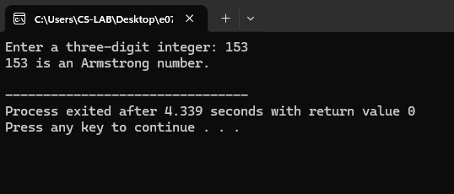

7. #include <stdio.h>
int main() {
int n, i;
float a, d, r, term;
printf("Enter the first term (a): ");
scanf("%f", &a);
printf("Enter the number of terms (n): ");
scanf("%d", &n);
printf("Enter the common difference for AP (d): ");
scanf("%f", &d);
printf("Enter the common ratio for GP (r): ");
scanf("%f", &r);
printf("\nArithmetic Progression (AP) Series:\n");
term = a;
for (i = 0; i < n; i++) {
printf("%.2f ", term);
term += d;
}
printf("\n\nGeometric Progression (GP) Series:\n");
term = a;
for (i = 0; i < n; i++) {
printf("%.2f ", term);
term *= r;
}
return 0;
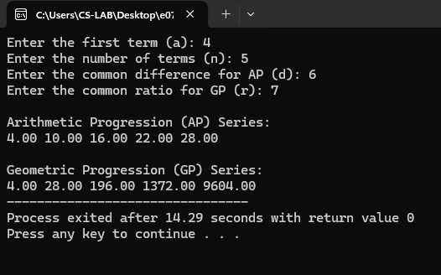

8. #include <stdio.h>
int main() {
int n = 5;
for (int i = n; i >= 1; i--) {
for (int j = 1; j <= i; j++) {
printf("*");
}
printf("\n");
}
return 0;
}
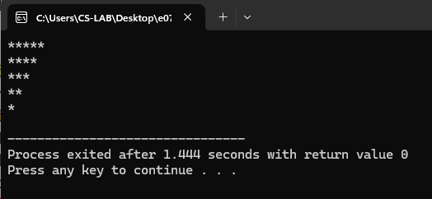

#include <stdio.h>
int main() {
int n = 5;
for (int i = n; i >= 1; i--) {
for (int j = 1; j <= i; j++) {
printf("*");
}
printf("\n");
}
return 0;
}

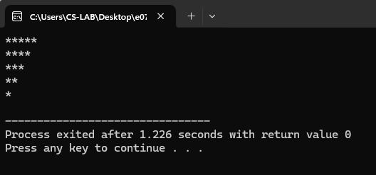

#include <stdio.h>
int main() {
int n = 5, count = 1;
for (int i = 1; i <= n; i++) {
for (int j = 1; j <= i; j++) {
printf("%d ", count);
count++;
}
printf("\n");
}
return 0;
}